LAB NO.: 1

INTRODUCTION TO BASIC LINUX COMMANDS

1. man (Manual)
- Function: Displays the manual pages for a command.
- Use Case: Learn how to use any Linux command.
- Syntax: man [command]
- Options:
  - man -k [keyword] – Search manual pages by keyword.
  - man -f [command] – Display brief description.
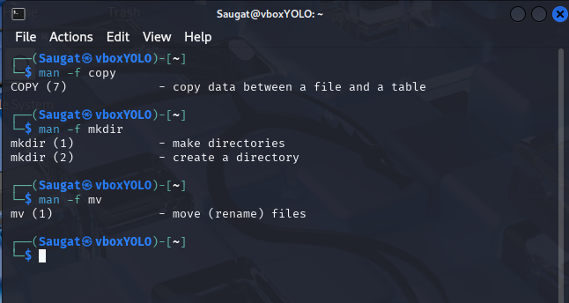
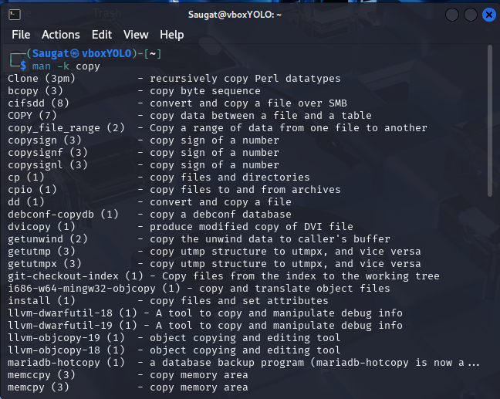
2. ls (List)

- Function: Lists files and directories in the current directory.
- Use Case: View contents of a directory.
- Syntax: ls [options] [directory]
- Options:

  - -l – Long listing format.
  - -a – Include hidden files.
  - -h – Human-readable file sizes (with -l)

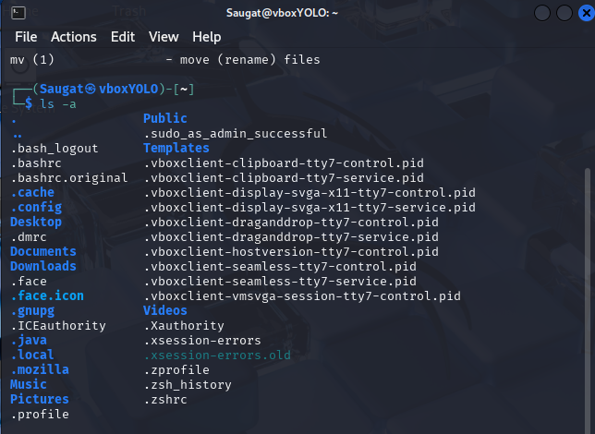

3. Dir

- Function: Also lists directory contents (similar to ls).
- Use Case: Basic file listing.
- Syntax: dir. [options] [directory]
- Options:
  - -l – Long format.

  - -a – Show all files including hidden ones.
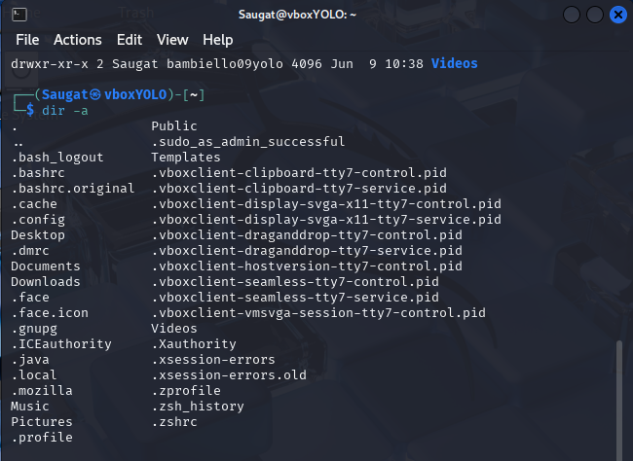

4. pwd (Print Working Directory)
- Function: Displays the current working directory.
- Use Case: Know your present location in the file system.
- Syntax: pwd
- Options:
  - -L – Logical path (default).
  - -P – Physical path (resolves symbolic links).


5. cd (Change Directory)
- Function: Changes the current working directory.
- Use Case: Navigate through the file system.
- Syntax: cd [directory]
- Examples:
  - cd .. – Go one directory up.
  - cd ~ – Go to home directory.


6. mkdir (Make Directory)
- Function: Creates one or more directories.
- Use Case: Create folders.
- Syntax: mkdir [options] [directory_name]
- Options:
  - -p – Create parent directories as needed.
  - -v – Show what’s being created
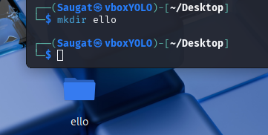

7. touch
- Function: Creates empty files or updates timestamps.
- Use Case: Quickly create a new file.
- Syntax: touch [filename]
- Options:
  - -c – Do not create file if it doesn’t exist.
  - -t – Set specific time.
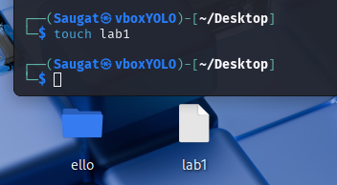
8. vim
- Function: Opens the vim text editor.
- Use Case: Edit or create text/code files.
- Syntax: vim [filename]
- Modes:
  - Insert mode: i to type.
  - Command mode: : to enter commands.
  - Save and exit: :wq
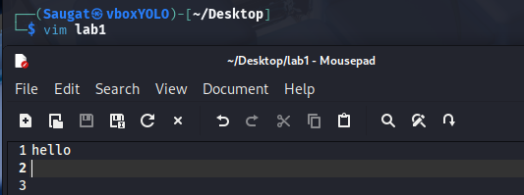

9. cat (Concatenate)
- Function: Displays contents of files.
- Use Case: View file contents quickly.
- Syntax: cat [file]
- Options:
  - -n – Number lines.
  - >, >> – Redirect output to a file.
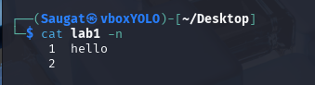
10. cp (Copy)
- Function: Copies files or directories.
- Use Case: Duplicate files or folders.
- Syntax: cp [options] source destination
- Options:
  - -r – Recursive copy for directories.
  - -i – Prompt before overwrite.
  - -v – Verbose output.
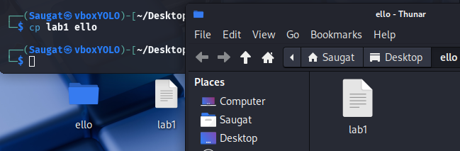

11. mv (Move/Rename)
- Function: Moves or renames files/directories.
- Use Case: Move or rename a file.
- Syntax: mv [source] [destination]
- Options:
  - -i – Confirm before overwrite.
  - -v – Verbose output.
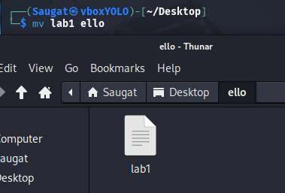
12. rm (Remove)
- Function: Deletes files or directories.
- Use Case: Remove unnecessary files.
- Syntax: rm [options] [file/directory]
- Options:
  - -r – Recursively delete directory.
  - -f – Force deletion without prompt.
  - -i – Prompt before each deletion
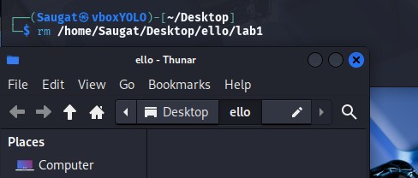
13. rmdir
- Function: Removes empty directories.
- Use Case: Clean up empty folders.
- Syntax: rmdir [directory_name]
- Options:
  - --ignore-fail-on-non-empty – Ignore errors for non-empty dirs.
  - -p – Remove directory and its parents if they become empty.
